**【ISIC - International Seminar on Investment Casting】**

The ISIC has been served as a premier platform where could carry the latest notions and researches of the investment casting. With the discussion and exchange during seminar, the international academic communication and cooperation would be enhanced.

The 10th ISIC will be held in Taichung/Taiwan on 13th~15th November, 2019. It is also a great pleasure for TFS (Taiwan Foundry Society) to be the host again of this great event.

**Let’s show you the foundry industry in Taiwan possesses the following traits:**

**. Outstanding capability for producing various superalloy materials.**

**. Fast design responses to manufacturing processes.**

**. One-step supply chain via an integrated production system.**

**As the host, we are sincerely welcome you to join 10th ISIC in Taiwan and share**

**your viewpoint with us as well as enjoy the beautiful landscape.**

**Date: 13th~15th November, 2019**

**Place: Nan Shan Education & Training Center (ETC)**

**─No. 300, Chenggong W. Rd., Wuri Dist., Taichung City, Taiwan─**

**On-Line registration: TBA**

|  |  |
| --- | --- |
| **Date** | **Program** |
| 13th Nov.  (Wednesday) | Industrial Visit Tour |
| 14th Nov.  (Thursday) | Expo,  ISIC Keynote Speech, Oral Presentation,  Welcome Party |
| 15th Nov.  (Friday) | Expo  ISIC Oral Presentation,  TFS Annual meeting,  Gala Dinner |

**【ISIC Seminar Program】**

1.Place：ETC –1F Hall 101

2.Note：Admission by the delegate badge.

Taiwan Foundry Society reserve the right to correct the program.

Mandarin/English/Japanese, simultaneous translation.

3.Content：TBA

4.Entry fee：

|  |  |  |  |
| --- | --- | --- | --- |
| **Category** | **Status** | **Fee(USD)** | **Contents** |
| ISIC Registration | Member | 400 | * Participation in the conferences * Proceeding w/E-file * 14th Nov. Welcome Party * 15th Nov. Lunch * Souvenir |
| Non-Member | 800 |
| Welcome Party | Member | 40 | Dinner of 14th Nov. |
| Non-Member | 70 |
| Gala Dinner | Member | 60 | Dinner of 15th Nov. ，Banquet |
| Non-Member | 120 |

* The fee of Expo & Plant Tour are exception.
* You shall be liable for all relevant bank transfer fees.

**【ISIC Industrial Visit Tour】**

1.Visiting Date：13th November 2019 (Wednesday)

2.Deadline of application：30th September 2019 (Besides until the participant full)

3.Note：Participant of each route are 40 people or less.

➢TFS reserve the right to adjust the route.

➢ The industrials have the right to winnowing the participant.

4.Route：TBA

5. Fee：100USD (Including Bus、Lunch、Group Insurance、Mineral Water)

**【ISIC-EXPO】**

1.Time：14th November (Thursday) 13:00PM ~ 17:30PM (10:30AM for Move-in and decoration)

15th November (Friday) 9:00AM ~ 16:00PM

2.Place：ETC –1F Hall 102

3.Booth arrangement：

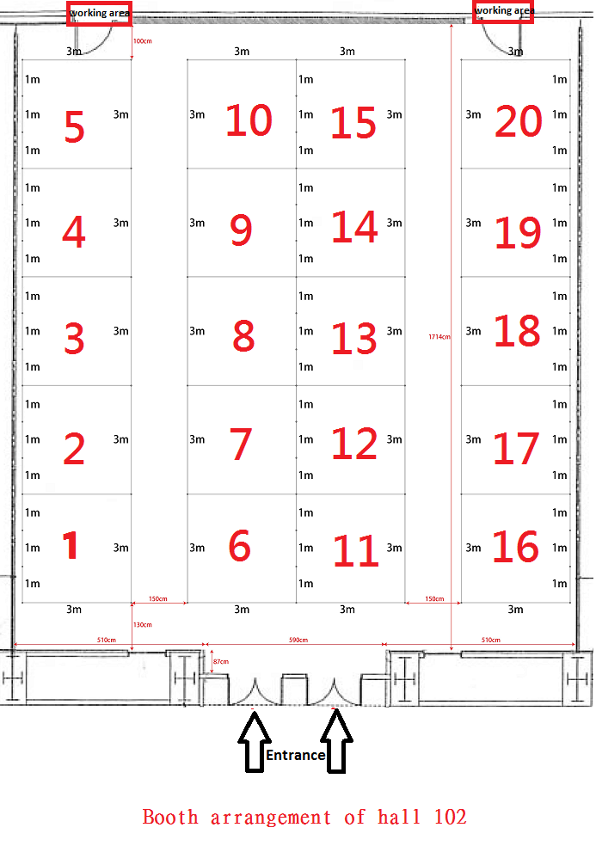

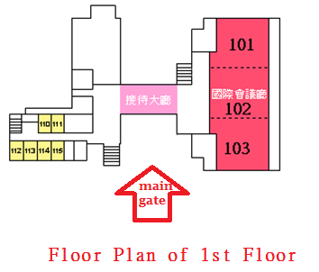

4.Registration：(Before 15th August 2019 or full registration)

|  |  |  |  |
| --- | --- | --- | --- |
| **ISIC EXPO REGISTRATION** | | | |
| Company name | (It’ll show on the booth) | Boss |  |
| Contact person |  | E-Mail |  |
| ADD |  | TEL |  |
| FAX |  |
| Membership & price | □Member USD$1,660 □Non-member USD$2,330元  Belong to which association - ___________________________________ | | |
| Booth No. | 1st selection： ；2nd selection： ；3rd selection： | | |
| 備註 | 1.Prices are for 2 days exhition. Booth size is 3x3x2.5m with back board； 5A/110V power socketx1、table(with tablecloth)x1、chairx2.  2. 1 person for Free Registration ISIC seminar and gala dinner. And one standard double room of Freshfields Resort(www.freshfields.com.tw/).  3. Please send back the filled form to Taiwan Foundry Society. And remit the amount by the following payment method. The booth you selected will be held under the complete payment.(You shall be liable for all relevant bank transfer fees.)  Bank transfer  Please Payable to  MEGA INTERNATIONAL COMMERCIAL BANK CO.,LTD，  NEW YORK AGENCY (SWIFT：ICBCUS33, CHIPS NO.908 OR FEDWIRE ROUTING NO.026009085) FOR CREDIT TO MEGA INTERNATIONAL COMMERCIAL BANK CO., LTD TREASURY DEPT (UID NO.321402) IN FAVOR OF  **MEGA INTERNATIONAL COMMERCIAL BANK CO., LTD，KAOHSIUNG METROPOLITAN BRANCH**  **A/C NO：002-53-02155-5**  **A/C NAME：Taiwan Foundry Society**  4.Contact us：Taiwan Foundry Society / Samira Yang  TEL：+886(0)7-3534791 FAX：+886(0)7-3524989 E-Mail：foundry@seed.net.tw | | |

**【ISIC Sponsorship proposal】**

|  |  |  |  |  |  |  |
| --- | --- | --- | --- | --- | --- | --- |
| **Amount(USD)**  **Content** | **680** | **1,000** | **1,700** | **2,400** | **3,350** | **5,000** |
| Free registration (1person)note1 | 1 | 1 | 2 | 2 | 4 | 4 |
| Gala dinner (1person) |  | 1 | 2 | 2 | 4 | 4 |
| Freshfields Resort  (Double/1 room/2 breakfast) |  | 1 | 1 | 1 | 2 | 2 |
| ISIC-Expo  (1 booth) |  |  |  |  |  | 1 |
| TAKU ironware – Iron pot |  |  | 1 | 1 | 1 | 1 |
| TAKU ironware – Tea pot |  |  |  |  | 1 | 1 |
| Publicity Materialnote2 |  |  |  | V | V | V |
| Sponsor Logo Exposure and link on TFS Webnote3 |  |  |  | V | V | V |
| Sponsor Logo Exposure on the cover of the 「Proceeding」 |  |  |  | V | V | V |
| Normal Advertisement in the「Proceeding」  (A4 size/1 page/color) | V | V |  |  |  |  |
| Thick insert advertisement in the 「Proceeding」  (A4 size/1 page/color/only 6 page) |  |  | V |  |  |  |
| Advertisement inside bottom of the 「Proceeding」  (A4 size/1 page/color/only 2 page) |  |  |  | V | V |  |
| Advertisement on bottom of the 「Proceeding」  (A4 size/1 page/color/only 1 page) |  |  |  |  |  | V |
| Sponsor Logo Exposure on the banners and indicator boards |  |  |  | V | V | V |
| Sponsor Logo on the banners of registration and platform  (3 sponsors limited) |  |  |  |  | V | V |
| Sponsor Logo on Seminar bag  (3 sponsors limited) |  |  |  |  | V | V |

Note：

* 1、ISIC Free registration includes Participation in the conferences, Proceeding w/E-file, 14th Nov. Welcome Party, 15th Nov. Lunch, Souvenir.
* 2、Publicity Material provided by sponsors and will be put into meeting bag.
* 3、TFS Web-site : [www.foundry.org.tw](http://www.foundry.org.tw)

Continue link till 1st Jan. 2021.

* The sequence of the advertisement page according to the amount of

direct sponsorship.

|  |  |  |  |  |
| --- | --- | --- | --- | --- |
| **ISIC Sponsorship Application Form** | | | | |
| Company |  | | Boss |  |
| Contact |  | | E-Mail |  |
| ADD |  | | TEL |  |
| FAX |  |
| Amount(Pls Check) | * 680 USD | * 2,400 USD | | |
| * 1,000 USD | * 3,350 USD | | |
| * 1,700 USD | * 5,000 USD | | |
| * Other:______________USD | | | |
| Note | 1.Send out the invoice after received application form  2.Provide the E-file of advertisement with 300DPI，before 2019/Aug.30th  3. You shall be liable for all relevant bank transfer fees. | | | |
| Contact us | Tel: +886 7-3534791~2  Fax: +886 7-3524989  E-Mail: [isic.twn@gmail.com](mailto:isic.twn@gmail.com)  [foundry@seed.net.tw](mailto:foundry@seed.net.tw) | | | |

**【Organizer】 【Joint Organized】**

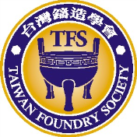   

**【Co-organized】**



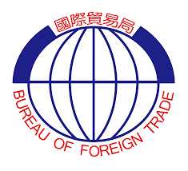**【Sponsor】**



**台灣鑄造學會**

**Taiwan Foundry Society**

**TEL: +886-7-353-4791~2**

**FAX: +886-7-352-4989**

**E-Mail: isic.twn@gmail.comisic.twn@gmail.com**

[**foundry@seed.net.tw**](mailto:foundry@seed.net.tw)

**Website:** [**www.foundry.org.tw**](http://www.foundry.org.tw)